***Language Skills***

1. ***Fill in the gaps with words given in the box. Change the form if necessary.***

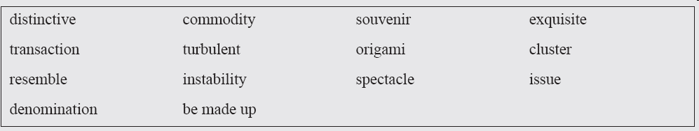

(1) At a local ___________ shop, my guide showed me a statue of the Happy Buddha.

(2) As the world economy continues to recover, ___________ prices will continue to rise again, with or without speculators.

(3) We just naturally think that the future will ___________ the past.

(4) This ___________ embroidery won people’s great admiration.

(5) The ___________ economic achievements in China in recent years are inspiring all Chinese people.

(6) Their fighting against the society triggered social ___________.

(7) There is talk that these two countries could go to war over a ___________ of disputed islands.

(8) A document is considered to ___________ of a number of topics, each with its own information type.

(9) The present international situation remains tense and ___________.

(10) As there is not enough metal for everyday use, each nation ___________ currency and agrees to relate the currency to gold or to what is called a gold standard.

***2. Translate the following sentences with the words given in the Brackets.***

(1) 锭币在形状上类似于儿童用纸折出的纸船形状，象征着繁荣昌盛。（resemble；prosperity）

(2) 中国的货币也不例外，印有毛主席头像的人民币见证了中国近代历史的发展。（display；testament）

(3) 封建帝制的结束，相继而来的动荡年代里产生了首批地方造币厂，然后是严重的通货膨胀和金融危机。（turbulent；inflation；instability）

(4) 随着秦朝的建立，最早的铜币在全国出现并开始流通。 （turn up；circulate）

(5) 保存完好的山西平遥城一度成为了全中国的金融中心。（well-preserved；financial center）